Sunday, July 9th – Set Up Day
10 am – 1 pm Fine Arts & Photography
10 am – 2 pm Domestic Art & Culinary Arts Canned Goods entries ONLY accepted
1 pm – 7 pm 4-H Booth Set up
5:00 pm Carcass Steer Weigh-In
6:00 pm Carcass Hog Weigh-In
6 pm – 8 pm Equine 4 Station Judging (Sawyer ring)
Monday, July 10th – Set Up Day
9 am – 11 am Culinary Arts Baked & Canned goods entries accepted
9 am – 9 pm 4-H Booth Set Up
9:00 am Carcass Goat & Carcass Lamb Weigh-In
2 pm – 4 pm Equine 4 Station Judging part 2 (Sawyer Ring)
4 pm – 7 pm Flower Show entries accepted (front of barn split door)
5:30 pm 4-H Fashion Revue (Historical Stage)
6:00 pm Horseperson Competition (Sawyer Ring)
6:30 pm 4-H Royal Court (Historical Stage)
6:30 pm Market Poultry Weigh-In
7:00 pm Market Weigh-In (in this order) Lambs, Goats, Dairy Feeders, Steers
7:15 pm 4-H Awards (Historical Stage)
11:59 pm Animal Arrival Deadline
Tuesday, July 11th – Opening Day, $2 Gate admission (Does not include rides)
8:00 am Admission gate C opens
8 am – 10 am Market Hog Weigh-In
8 am – 9:15 am Flower Show Entries taken (in front of flower barn – split door)
9:00 am Jr. Fair Equine Ranch Show (Sawyer Ring)
9 am – 4 pm Open Class Hay & Grain Entries taken (Agricultural Building)
10:00 am All Gates Open
10:00 am Opening Ceremony (Historical Stage)
10:00 am Exhibition Halls open
11:00 am Market Rabbit Weigh-In
11:00 am 4-H Booth judging
11:30 am Jr. Fair Coronation (Historical Stage)
12:00 pm Vendors Open
12:30 pm Harness Racing (Grandstands)
1:00 pm Jr. Fair Rabbit Showmanship (Rabbit Barn)
1:00 pm Flower Show Opens (Flower Barn)
1 pm – 5 pm Rides Open
5 pm – 8 pm Grant Street Exit (Bicentennial Stage)
5:00 pm Jr. Fair Staging for Parade (Jr. Fair area)
5:30 pm Harness Racing (Grandstands)
6 pm – 9 pm Jay Byrd
6 pm – 11 pm Rides Open
6:00 pm Jr. Fair Hog Showmanship
7:00 pm Jr. Fair Parade of colors & Patriotic Costume Class (Sawyer)
10:00 pm Gates Close
Wednesday, July 12th – Veterans & First Responders Day (free with proper ID)
8:00 am Admission Gate C Opens
9:00 am Jr. Fair Equine Western Show (Sawyer Ring)
9:00 am Jr. Fair Goat Show: Meat/ Specialty Showmanship, T.C. Born & Breed, Market, Clover Bud, Specialty Goat (Sale Ring)
9:00 am Open Class Specialty Goat Show to Follow Jr. Fair Goat Show
9:00 am Open Class Rabbit Show (Rabbit Barn)
Tuesday-Sunday Grounds Entertainment
Circus Incredible
Wee Wee Pig Races
9:30 am Jr. Fair Dairy Beef Feeder Show (Dairy Ring)
10:00 am All Gates Open
10:00 am Exhibition Halls Open
10:30 am Commissioners Meeting (Historical Stage)
12:00 pm Jr. Fair Rabbit Show: Pet, Market, & Breeds (Rabbit Barn)
12:00 pm Vendors Open
1 pm – 5 pm Rides Open
1:00 pm Clover Bud Show & Tell (4-H Block Building)
1:30 pm Clover Bud STEM activities
2:00 pm Jr. Fair Sheep Show (Dairy Ring)
2:00 pm Open Class Sheep to follow Jr. Fair
2 pm – 3:30 pm Warren Freestyle - Krav Maga (Bicentennial Stage)
3:00 pm Jr. Fair outstanding Dairy Contest Hands on Activity
3:30 pm Jr. Fair Dairy Production Test (Dairy Barns)
5:00 pm Steven Ceremunga Acoustic (Historical Stage)
5:00 pm Juvenile Characteristics (Bicentennial Stage)
6:00 pm Jr. Fair Swine Show (Sale Barn)
6 pm – 11 pm Rides Open
7:00 pm Rough Truck Show & Contest (Grandstands)
10:00 pm Gates Close
Thursday, July 13th
8:00 am Admission Gate C Opens
8:00 am Muddying of Horses for Groom N’ Clean Contest (Equine)
9:00 am Jr. Fair Cat Show (Cat Barn)
9:00 am Jr. Fair Reptile Judging (4-H Block Building)
9:00 am Jr. Fair Poultry Showmanship, Market Show (Poultry Barn)
9:30 am Jr. Fair Dairy Show (Dairy Ring)
10:00 am All Gates Open
10:00 am Exhibition Halls Open
11:00 am Jr. Fair Equine Groom N’ Clean (Sawyer Ring)
11:00 am Jr. Fair Beef Showmanship (Sale Barn)
11:00 am Open Class Beef Show to Follow Jr. Fair
12:00 pm Vendors Open
12: 45 pm Spelling Bee Registration Deadline (Historical Stage)
1:00 pm Spelling Bee (Historical Stage)
“Sponsored by Trumbull County Retired Teachers Association”
1:00 pm Ty’s Tunes (Bicentennial Stage)
1 pm – 5 pm Rides Open
4:30 pm Jr. Fair Equine Contest Show (Sawyer)
5:00 pm The Band Hannah (Bicentennial Stage)
5:00 pm DJ Joe Raschilla (Historical Stage)
6:00 pm Jr. Fair Beef Show (Sale Barn)
6:00 pm Auto Races- BRP Modified Touring Series & Sportsman Modified Touring “Sponsored By King Brothers”
6 pm – 11 pm Rides Open
10:00 pm All Gates Close

Friday, July 14th
8:00 am Admission Gate C Opens
9:00 am Jr. Fair Poultry: Showmanship, Fancy (Poultry Barn)
9:00 am Goat Show: Showmanship, Dairy Breeds, Outstanding Project (Sale barn)
9:30 am Jr. Fair Pocket Pets Exhibition (Rabbit Barn)
10:00 am All Gates Open
10:00 am Jr. Fair Cavy Show (Rabbit Barn)
10:00 am Jr. Fair Equine Fun Show (Sawyer)
1 pm – 3 pm History of Mosquito Lake (Historical Stage)
1 pm – 5 pm Rides Open
4:00 pm Francis Tennant Memorial Versatility Tack Check
5:00 pm Open Class Dairy Show (Dairy Ring)
5:00 pm Francis Tennant Memorial Versatility Competition
6:00 pm Blue Siren (Historical Stage)
6:00 pm Buckeye Horse Pulls
6 pm – 11 pm Rides Open
6:30 pm OSTPA truck & Tractor Pulls (Grandstands) “Sponsored by Westfield Grains & Bortnick Tractor Sales, Inc.”
10:00 pm All Gates Close
Saturday, July 15th
8:00 am Admissions Gate C Opens
9:00 am Open Class Draft Horse Halter Judging (Draft Horse
10:00 am All Gates Open
10:00 am Area Exhibition hall Opens
10:00 am Open Class Drive-In Draft Horse & Halflinger Hitch Show
10:00 am Jr. Fair Equine English Show (Sawyer)
10:00 am Jr. Fair Dairy Judging Contest (Dairy Ring)
10:30 am Jr. Fair Livestock Sale (Sale Barn)
12:00 pm Vendors Open
1 pm – 5 pm Rides Open
1 pm – 4 pm Candace Campana (Bicentennial Stage)
2 pm – 3:30 pm Infini Tribe (Historical Stage)
2 pm – 7 pm Motorcycle Show at Grandstands
6:00 pm Against the Wind (Historical Stage)
6:00 pm High Steel Rodeo “Bulls & Barrels” (Grandstands) Sponsored by Bortnick Tractor Sales, Inc.
6 pm – 11 pm Rides open
10:00 pm All Gates Close

Sunday, July 16th
8:00 am Admission Gate C Opens
8:00 am Super Showman Competition (Sale Barn)
9:30 am Bazetta Christian Church Service
10:00 am Exhibition Halls Open
12:00 pm Vendors Open
12:00 pm Cow Milking Contest (Milking Parlor)
1 pm – 3 pm Natural History of Bazetta Area (Historical Stage)
1:00 pm 4-H Public Speaking Contest
1:00 pm Small Animal Dress-Up Contest
1 pm – 4 pm Karaoke (Bicentennial Stage)
1 pm – 5 pm Rides Open
1:30 pm Cloverbuds Stick Horse Costume Class
2:00 pm Jr. Fair Cheese Auction (Dairy Ring)
2:00 pm Dress a Kow Contest (Dairy Ring, Follows Auction)
2:00 pm Pee Wee Dairy Showmanship (Dairy Ring, to Follow Above)
2:00 pm Jr. Fair Equine Costume Contest (Sawyer)
4:30 pm Release of Champions Only
5:00 pm Speed Limit (Historical Stage)
5:00 pm Thunder Creek Band (Bicentennial Stage)
5:00 pm Demo Derby (Grandstands) “Sponsored By Mark Thomas Ford”
5:30 pm Release Large Animals
6 pm – 11 pm Rides Open
7:00 pm Release Small Animals
8:00 pm Release Culinary Arts, Domestic Arts, Fine Arts, Photography, and Hay & Grains
9:00 pm Gates Close
9:30 pm Fireworks Show
10:00 pm Release of Camper
11:00 pm Release of Vendors & Concessions
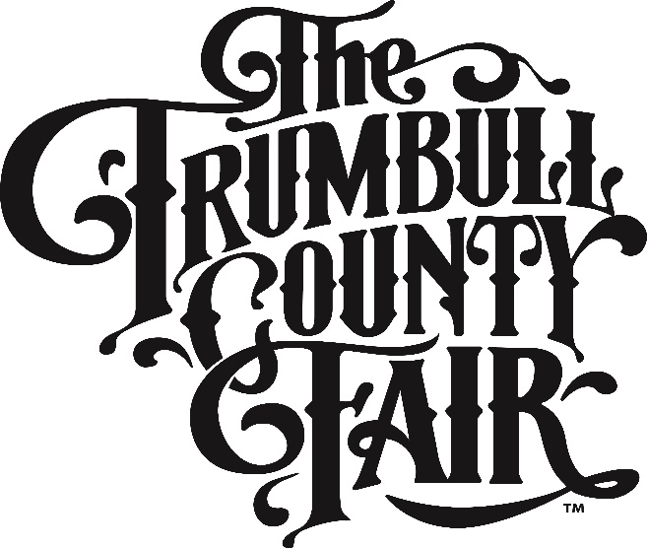
2023 Schedule of Events
July 11-16 2023

Gates C opens at 8:00 AM All remaining gates open at 10 AM
Gates Close at 10 PM Tues-Sat. Gates Close at 9 PM on Sunday

Exhibition Halls Open at 10 AM
Vendors & Midway Open at Noon

Rides 1-5 PM *** 6-11 PM

